Nama : Fadzlan Ilham I

NIM : 18090060

Kelas : 5A

**Praktikum 2**

1. Source Code

application/views -> viewlatihan1.php

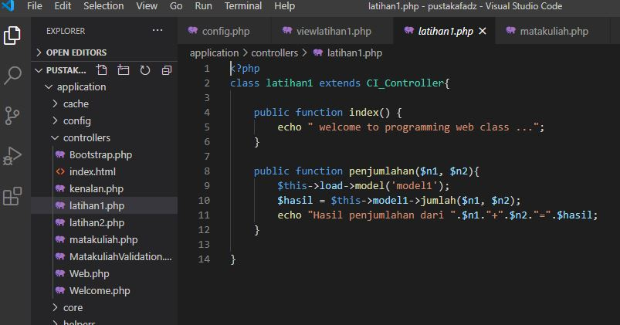

application/controllers -> latihan1.php



application/controllers -> latihan2.php

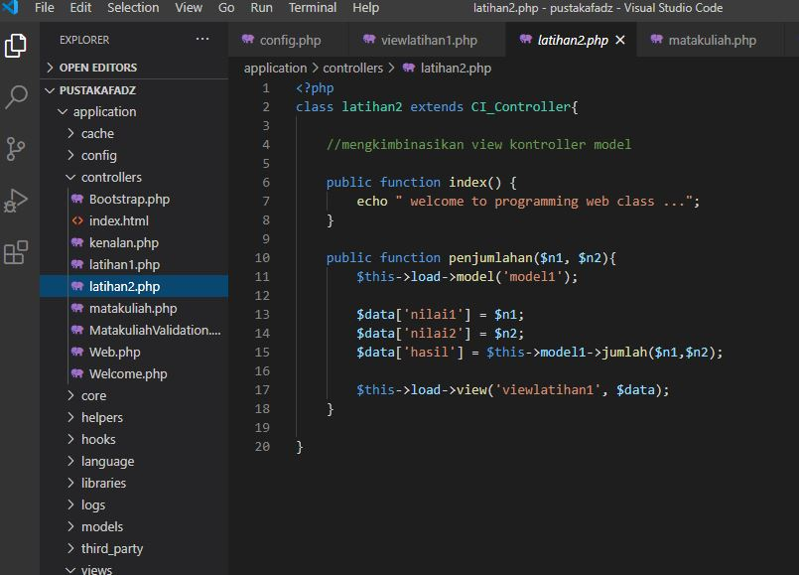

application/models -> model1.php

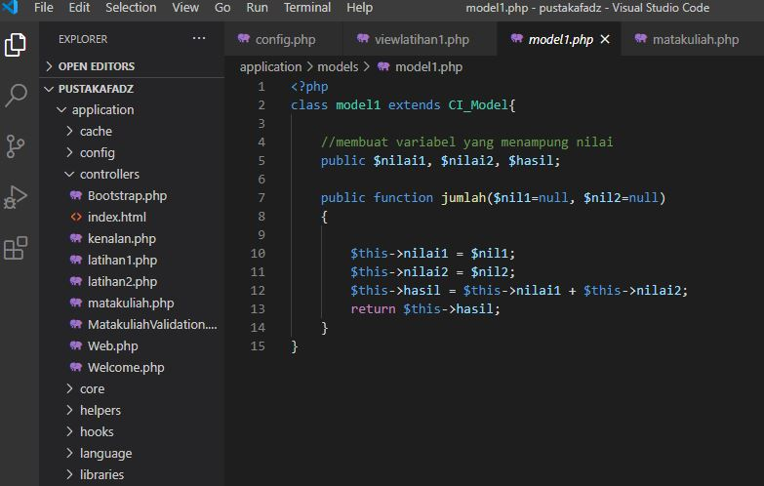

1. URL

[http://localhost/pustakafadz/latihan1](http://localhost/5/pustakachoco/index.php/latihan1)

[http://localhost/pustakafadz/latihan1/penjumlahan/4/6](http://localhost/5/pustakachoco/index.php/latihan1/penjumlahan/4/5)

[http://localhost/pustakafadz/latihan2/penjumlahan/1/1](http://localhost/5/pustakachoco/index.php/latihan2/penjumlahan/1/1)

1. Capture Hasil

